**Absolute Motor Zero Positions**:

Joint 1 and 4 Absolute Motor Zero Positions:

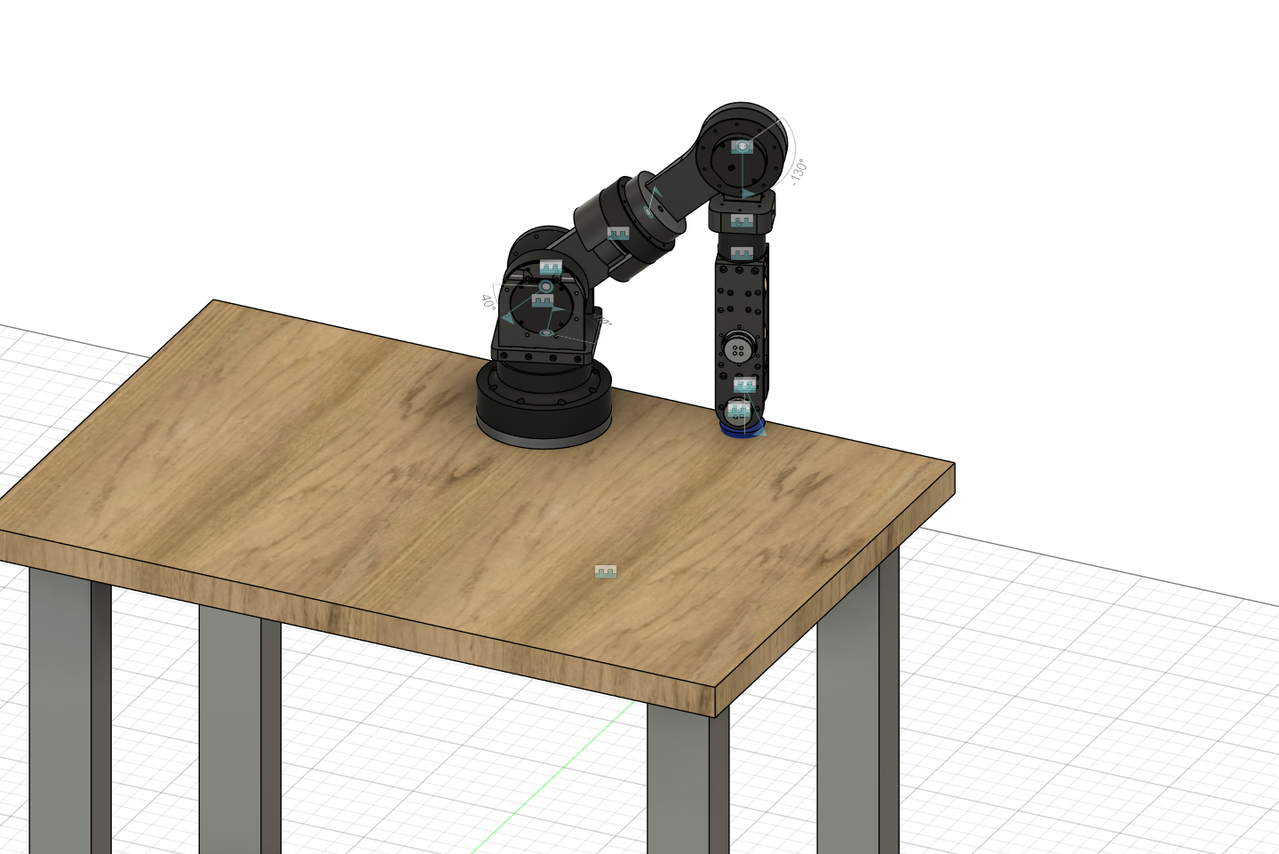

*Joint 1 is aligned such that the end effector meets the edge of the table (CW Positive Looking Into Rotor)*

*Joint 4 is aligned to the lower physical limit.(CW Positive Looking Into Rotor)*

*Joints 2 and 3 Motor Zero Positions*:

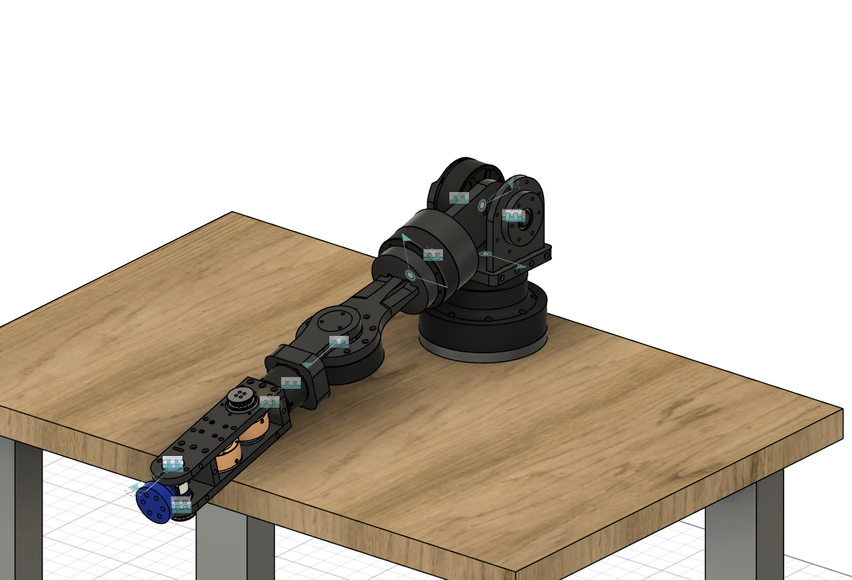

*Joint 2 is aligned with the lower physical limit (CW Positive Looking Into Rotor)*

*Joint 3 is aligned with the textured face facing up (CW Positive Looking Into Rotor)*

Joint 5 Motor Zero Position:

Conduit exit is rotated 90 CW from facing up. I.e. When looking at the robot from the front of the table, the conduit exit is pointing to the right.

Joint 6 and 7 Motor Zero Positions:

TBD; May or may not be needed? Could probably just set a virtual zero that makes the end effector zero straight out the end

**Virtual Home, Zero Positions, and Joint Limits**:

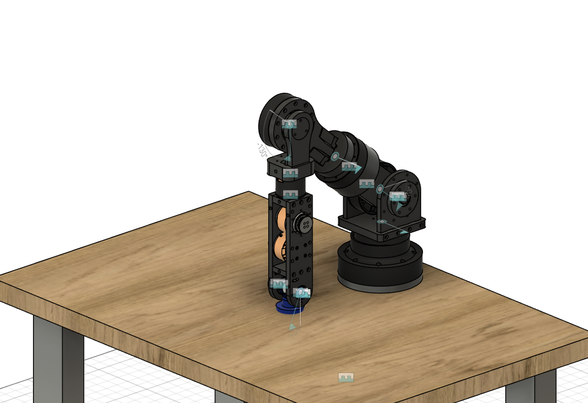

The Robot’s virtual home is shown above. This represents a shutdown safe position that is not susceptible to collapsing.

| Joint | Angle Limit Low  (deg - multi) | Angle Limit High  (deg - multi) | Virtual Home Angle  (deg - multi) | Positive Direction Looking Into Rotor |
| --- | --- | --- | --- | --- |
| 1 | 0 | 210 | 106.3 | CW |
| 2 | 5 | 215 | 63.6 | CW |
| 3 | -30 | 225 | 86.8 | CW |
| 4 | 2.5 | 245 | 1 | CW |
| 5 | -30 | 210 | 89.23 | CCW |
| 6 |  |  |  | CCW |
| 7 |  |  |  | CCW |

**Motor Specifications and Accelerations**:

| **Joints** | **Max Torque (Nm)** | **Rated Torque (Nm)** | **Gear Ratio** | **Max Speed (rpm)** | **Conservative Range (deg/s²)** | **Typical Range (deg/s²)** | **Aggressive Range**  **(deg/s²)** |
| --- | --- | --- | --- | --- | --- | --- | --- |
| **J1–J2** | 28 | 14 | 9 | 177 | 200–400 | 400–800 | 800–1200 |
| **J3–J4** | 20 | 10 | 9 | 178 | 200–400 | 400–800 | 800–1200 |
| **J5** | 4.5 | 2.5 | 10 | 260 | 300–600 | 600–1000 | 1000–1500 |
| **J6–J7** | 2.5 | 1 | 10 | 253 | 300–600 | 600–1200 | 1200–1500 |